PBLIF1-4
Diet For Beginners
1.Use Case Diagram
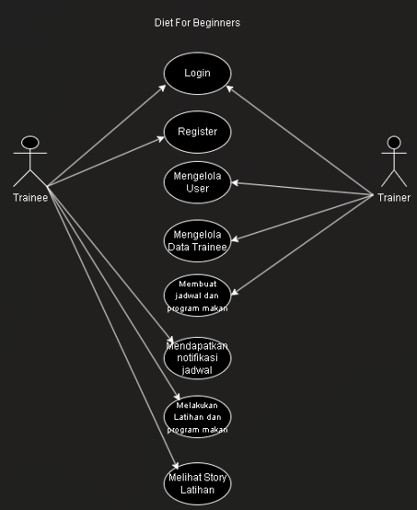

2. ERD
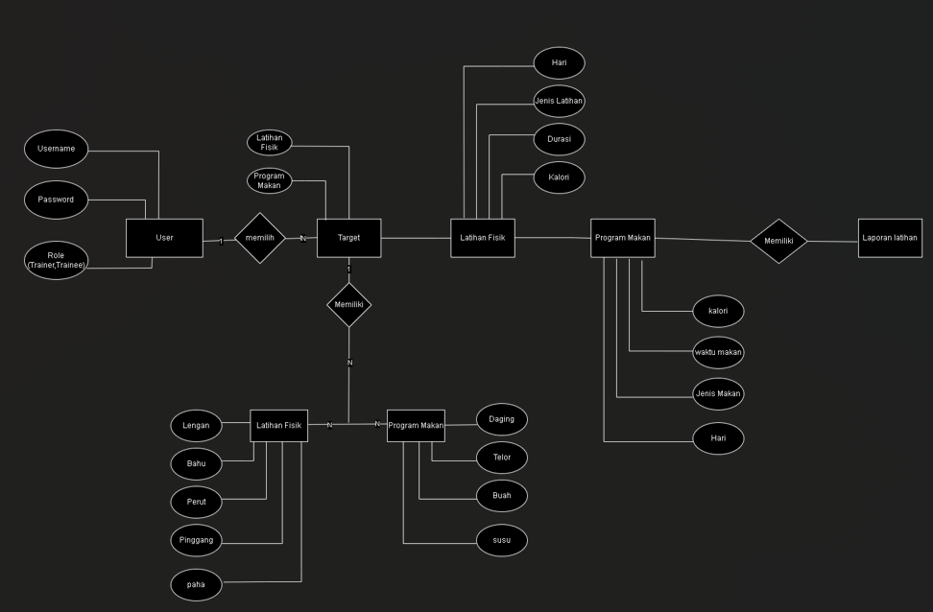

Nama Anggota kelompok :
Rivaldo Franscisco | 3312401098
Andre Nataniel Simbolon | 3312401089
Marwan Siburian | 3312401101
Rafa Adestia Atin | 3312401091
Gisella Laudia Perangin- Angin | 3312401109

